Dentistry for Horses

|  |
| --- |
| Your horse’s dental hygiene is directly correlated to overall performance.  The domestication of horses has led to dramatic changes in diet and life style, resulting in different chewing motions and dietary demands.  Proper dental care with routine examinations and floats are important for ensuring your horse stays at the top of his or her game. |
|  |  |

*Copper Country Veterinary Clinic–Dr. Rebecca Vollrath, DVM, CVA*

# A word on the importance of good oral health

Horses are designed to forage 24 hours a day. Their teeth are made to constantly erupt throughout their life to accommodate for this lifestyle. The adult teeth of humans, dogs, and cats erupt once to replace baby teeth. Horses’ adult teeth replace baby teeth by five years of age and then continue to erupt throughout the course of their lifetime. Along with advances in equine medical knowledge and treatment, the life expectancy and quality of life of horses has continued to improve. Proper dental care for horses has been instrumental in this progression.

## Dental Anatomy

Horses have 36-44 teeth, depending on sex and whether or not wolf teeth are present. The teeth seen when the lips are parted are the incisor teeth responsible for prehending forage into the mouth. The cheek teeth are the three premolar and three molar teeth in each quadrant of the mouth responsible for grinding feed prior to swallowing. The first set of teeth are called deciduous (or baby) teeth, which are lost and replaced by adult teeth in a systematic manner until five years of age.

# Dental Float

As a horse’s teeth continually erupt and grind against opposing teeth during chewing, sharp enamel points develop. These points can cause ulcerations of the cheeks and tongue. Discomfort when chewing can alter how your horse chews feed, resulting in more significant changes such as ramps, wave mouth, hooks, and steps. All of these changes affect your horse’s ability to efficiently chew food for maintaining condition.

A dental float involves reducing these sharp enamel points and correcting other abnormalities using a combination of power tools and hand floats. A veterinarian will perform a thorough physical exam to identify other concurrent medical conditions prior to sedation. A speculum is placed to open the mouth and allow for visualization of the back of the mouth.

The goals of dentistry include not only floating sharp points, but also improving chewing, providing pain relief, and promoting general health, productivity and longevity. -AAEP

# Clinical signs of dental disease

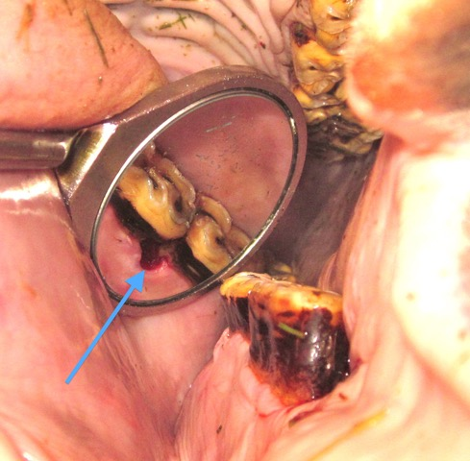

Source: AAEP

Contact Us

**Copper Country Veterinary Clinic**

904 W Sharon Ave  
Houghton MI 49931

906-482-1771

ccvc@pasty.net

ccvc.cc



Many horses will have changes occurring inside the mouth without signs detectable by their owners. These changes can lead to discomfort and difficulty in chewing feed appropriately. As dental disease progresses, clinical signs include the following:

* poor performance, e.g., resistance to the bit and head tossing;
* weight loss;
* dropping feed;
* the presence of undigested feed in manure;
* quidding, or dropping large balls of forage from the mouth;
* foul breath;
* and nasal discharge.

The primary goal of routine dental floats is to catch and correct changes before significant disease develops. Early detection of dental disease and preventative maintenance is key to protecting your horse’s health.

### Q: Who should perform dental care for my horse?

**A:** Dentistry is more than floating teeth. It involves examination of the entire mouth, teeth, and associated head structures including the sinuses. Dental disease can affect the entire body; therefore, early recognition and prevention is of utmost importance. A veterinarian is best equipped to treat not only the mouth but also the rest of your horse.

### Q: How often should my horse’s mouth be examined?

**A:** Horses under five years of age should have an oral exam at the time of their first foal exam, as a yearling, and every six months between the ages of two to four. This timing allows a veterinarian to examine for congenital defects or other abnormalities that can lead to long-term consequences while teeth are erupting. Adult horses should be examined annually to detect pathology early before it can cause severe disease. Senior horses (over 20 years) should be examined consistently because they are at risk for periodontal disease, excessive wear, and malalignment.

# part of your horse’s comprehensive health-care plan

Routine dental care is integral to your horse’s overall well-being. We recommend an annual physical examination for all horses, along with regular vaccinations, Coggins testing, fecal egg counts, and routine dental care. Copper Country Veterinary Clinic strives to provide early recognition of disease and preventative medicine to promote a long, healthy, and productive life for your horse. Contact us today if you have questions about routine care for your horse or other services we offer.

|  |  |
| --- | --- |
| Copper Country Veterinary Clinic  904 W Sharon Ave Houghton MI 49931 |  |
|  | **[Recipient Name]**  [Street Address] [City, ST ZIP Code] |