Vaccinations for Horses
Vaccinations are essential for protecting your horse against deadly diseases.
Many equine vaccinations protect against viruses that cause serious (often fatal) neurologic disease in horses. These diseases are moving north, with reported cases in Wisconsin in 2016.
Even if your horse does not leave the farm, vaccinations can provide herd immunity and further protection, preventing the spread of infectious disease.
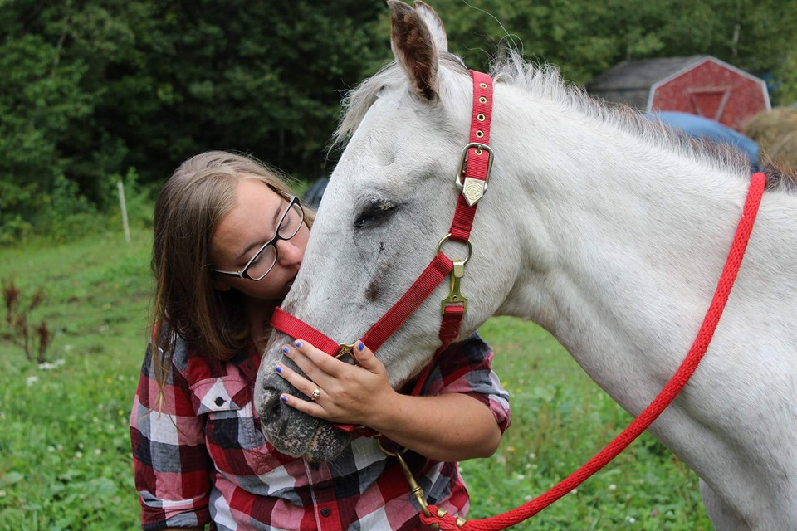
  - Copper Country Veterinary Clinic–Dr. Rebecca Vollrath, DVM, CVA

core vaccinations
Core vaccinations that the American Association of Equine Practitioners recommends administering annually include Eastern Equine Encephalitis (EEE), Western Equine Encephalitis (WEE), Tetanus, West Nile Virus (WNV), and Rabies. These diseases are often fatal in horses. A combination vaccine comprised of EEE/WEE/Tetanus/WNV is often administered, but it only provides six months of protection. Therefore, the timing of these vaccines is important: they need to be administered when horses are most at risk for contracting disease (late spring through early fall). In Michigan’s Upper Peninsula, these vaccines should be given no earlier than March 1.

Tetanus (Lockjaw)
Tetanus is caused by a clostridium bacteria that produces spores in the intestinal tract of animals or in the environment, especially soil. These spores are very hardy and can survive for years in the environment. Horses can contract tetanus when the spores enter a wound, such as a laceration or puncture, and foals can be exposed to the disease through the umbilicus. Once the spores enter the body, they proliferate and release toxins. The toxins affect the junctions between nerves and muscles, leading to muscle rigidity, hypersensitivity to sounds, a “sawhorse stance,” and eventually respiratory depression. While not communicable between horses, tetanus is often fatal once a horse is infected.
This vaccine is recommended annually. Mares and foals may have additional boosters based upon risk factors.

Encephalitis (Eastern and Western)
Eastern and Western Encephalitis are transmitted by mosquitoes, causing nearly fatal neurologic disease. The vaccines available for these diseases are only protective for six months. In the Upper Peninsula, encephalitis risk is virtually nonexistent in the winter months in the absence of mosquitos, so these vaccines provide the best protection when given in springtime.

West Nile Virus (WNV)
Mosquitoes are also the disease vector for West Nile Virus, which causes neurologic disease. Clinical signs of disease include muscle tremors, skin hypersensitivity, and ataxia (incoordination). While less fatal than encephalitis, WNV can still be difficult and expensive to treat. Humans can also contract WNV; the same mosquito that transmits the disease to your horse can also give it to you. However, the virus is not transmissible between you and your horse. Because this vaccination is also only effective for six months—and most horses are affected by WNV in late summer/early fall—make sure your spring vaccination is administered late enough to protect your horse during the endemic time.

Rabies
Rabies is a fatal viral infection of mammals that is transmitted through the bite of an infected animal. Raccoons and skunks are common carriers of this disease. Because Rabies is a zoonotic disease, your horse can transmit it to you. The vaccine, which is very effective, is only required annually.

Non-Core Vaccinations
Non-core vaccinations protect horses that are at higher risk of contracting diseases such as influenza/rhinopneumonitis, strangles, and Potomac Horse Fever. Your veterinarian will help determine the risk status for your horse and farm for these diseases before recommending vaccinations.

Influenza/Rhinopneumonitis
Here at Copper Country Veterinary Clinic (CCVC), we carry the influenza/rhinopneumonitis vaccination, which is recommended for horses that either travel or are exposed to horses that travel. While the rhinopneumonitis vaccination can help protect against the respiratory herpesvirus pathogen, it does not prevent the neurologic or abortion form of the herpesvirus-1 pathogen that is often covered by the media. Please contact us if you have concerns about herpesvirus-1; we can provide the most up-to-date information on protecting your horse, including recommendations for pregnant mares.

Strangles
Strangles is often seen in young horses that travel, due to the increased risk of exposure to the bacteria through aerosols and nasal secretions. The disease causes abscesses within lymph nodes, typically around the throatlatch, and nasal discharge. In rare cases it can spread to the abdomen or cause an autoimmune disorder known as purpura hemorrhagica, which results in red spots on the skin and mucous membranes caused by bleeding from capillaries as well as edema (swelling) of the limbs and the head. Most cases of Strangles will resolve with time, but careful quarantine is required, as this disease is highly contagious. While the vaccine can help protect your horses, there are some risks, and it is not always recommended.

Potomac Horse Fever
Potomac Horse Fever can cause debilitating gastrointestinal disease and laminitis. This disease is less common in the Upper Peninsula, and the vaccine has not been proven to be 100 percent effective at preventing disease. Currently we do not carry a vaccination for Potomac Horse Fever at CCVC, but if you have concerns about this disease, please speak with Dr. Vollrath.
Vaccinations protect not only your horse, but also the greater horse community through the process of “herd immunity.”

part of your horse’s comprehensive health-care plan
We recommend an annual physical examination for all horses, along with regular vaccinations, Coggins testing, fecal egg counts, and routine dental care. CCVC strives to provide early recognition of disease and preventative medicine to promote a long, healthy, and productive life for your horse. Contact us today if you have questions about routine care for your horse or other services we offer. Vaccinations are also part of our wellness program to help you manage the costs of your horse’s veterinary care.
Copper Country Veterinary Clinic
904 W Sharon Ave
Houghton MI 49931
[Recipient Name]
[Street Address]
[City, ST ZIP Code]

